Shabbos Stories for
Parshas eikev 5773
Volume 4, Issue 47 20 Menachem Av 5773/ July 27, 2013
For a free subscription, please forward your request to keren18@juno.com

Running on Ocean Parkway On Shabbos Day
By Rabbi Elazar Meisels

Recently, a guest at our Shabbos table shared the following story:
I have a close friend who is Jewish but not observant. She harbors warm feelings for Jewish tradition and frequently raises points regarding Judaism in our conversations. In our latest conversation, she told me about something that she saw and how it shaped her opinion about Orthodox Jews and Shabbos.

Her Friend Enjoys Training for
And Running in Marathons
One of her hobbies is running marathons, and she trains avidly for them. This involves running long distances in all sorts of weather to help build up her stamina and endurance. Although she lives in Manhattan, one of the routes she takes when running is to cross the Brooklyn Bridge, run alongside the Prospect Expressway to Ocean Parkway and then continue all the way down to Coney Island and back.

Thought that the Orthodox Jews
Were Overdressed in the Heat
Not long ago, she ran this route on a Shabbos morning, and she was struck by the fact that the Orthodox Jews she saw were so overdressed in the heat and that they clung so rigidly to their ways. She found it strange that none of them were carrying or using their cellphones or driving a car. She knows that this is what Jewish law mandates, but she doesn't seem to have any appreciation for it. She thinks that if this is what Shabbos requires of us, it's not something that she can relate to.
My guest admitted that she hadn't responded, because she wasn't sure how to answer her. She wondered what I would say about the story.
To me, the answer is rather obvious.
Instead of defending Shabbos or the laws of modesty, I would have shared with her my own amazement at a scene I witnessed recently.
Recently , on a Shabbos morning, I was walking on Ocean Parkway on the way to a friend's kiddush. It was a rather warm day, and I tried to walk slowly so as not to overexert myself and work up a sweat.

Astonished by a Young Couple
Running and Sweating Profusely
To my astonishment, I noticed a young couple running down Ocean Parkway, and they were sweating profusely. They were literally dripping water, and, if not for the water bottles strapped to their backs they would have been in danger of dehydrating. Every so often they stopped for a quick drink and then resumed their frenetic pace. They looked like they had run all the way from Manhattan.
There was no one chasing them, so I assumed that they were running for recreational purposes. Who knows - maybe they were training for a marathon. They wore only shorts, t-shirts, and running shoes; a rather strange outfit to wear in public. They also looked like they hadn't eaten a decent meal in years. Each was quite thin and looked somewhat emaciated.

It Appears to Me to
Be Entirely Pointless
I'm not a runner, but all I know is that if this is what running demands of us, I want no part of it. It looks incredibly sweaty, draining and uncomfortable. It appears to be entirely pointless. After all, why run all the way from Manhattan to Coney Island when, after only five minutes, you'll have to turn back and run all the way back to Manhattan?
Essentially, in this situation, she made my argument for me. Her own actions demonstrated that she understood very well the importance of sacrificing for a greater goal. The only difference was in our goals. She saw the value in running, whereas we see the value in dressing modestly and disengaging from the material world one day each week.
Instead of trying to "defend" Shabbos, it would be wiser in many cases, to demonstrate to the doubter how his own actions indicate that he understands perfectly well the idea of sacrificing for a higher ideal. After all, it's hard to disagree with oneself.

Reprinted from last week’s email of Partners in Torah Mentor Talk

The Last Row-House Shul in Philly: New Lease on Life for Remnant of Neighborhood’s Jewish Past
By Howard Shapiro

The “Little Shul,” as its supporters call it, stands in the middle of a dense street of row homes. But in a big way, it stands alone.
It is the last operating row-house shul in South Philly. During the early part of the last century, there were 155 synagogues like it in the neighborhood, dotting the narrow streets. These buildings were hives of activity on Saturday mornings, when worshippers packed into confined sanctuaries that otherwise would have been used as stores or living rooms.

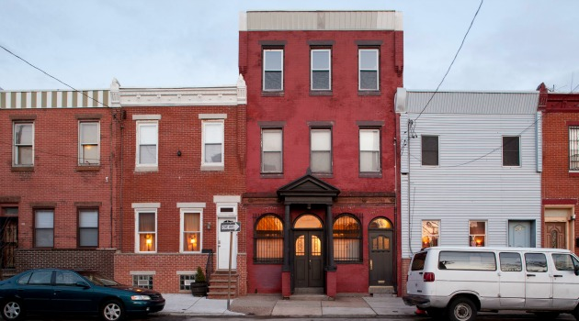

Nowadays, you could walk past the Little Shul — its real name is Congregation Shivtei Yeshuron Ezras Israel — and not even know it’s there. Except for its pillared entrance and some small lettering, it’s like almost every other place on the blocks around it — snug in a long line of two- and three-story homes older than just about anyone now alive, in a hardscrabble neighborhood where a different ethnicity moves in with each new generation.
Shivtei Yeshuron still operates because a handful of people persist in keeping it alive. A few years ago that handful — mainly families with deep roots at the shul — was its entire membership. Now there may be as many as 18 or 35 members, depending on who’s counting, and more may be coming. Shivtei Yeshuron is suddenly in the limelight, receiving more attention than it has seen in decades, and possibly in its entire history. That’s because Hidden City, a group that runs a festival highlighting unusual spaces in Philadelphia, has made it a featured place. That, in turn, has brought people into its faded but intact sanctuary.

Hoping to Gain New Members
At $36 per person for an annual membership — double chai — Shivtei Yeshuron stands to gain new blood. Whether that means active members or simply new supporters with a membership remains to be seen. But the fact is, this Orthodox Little Shul that was once a player among many players, that hosted its last bat mitzvah in 2000 and last bar mitzvah the decade before that, is now a standout.
“It’s such a unique location — there’s really nothing like this storefront synagogue,” says Lee Tusman, 31, the creative director of Hidden City Philadelphia, which is supported by members, foundations and grants. In June, Hidden City ran its second festival — the first was in 2009 — that temporarily installs art in spaces people might walk or drive by, but wouldn’t necessarily enter.

Uncelebrated and Faded
Many of these places, like Shivtei Yeshuron, are venerable and still part of the city’s life, but also uncelebrated and faded. (“Faded” literally describes the cover on the table at Shivtei Yeshuron’s bimah in the middle of the 90-seat sanctuary; the velvet on a portion of the table cover is worn thin from decades of use.)
“A bunch of different kinds of people have been coming through,” says Tusman, “not just people coming to the festival but also a group of people who come out of the woodwork and say, ‘I knew about this synagogue’ or ‘my ancestors were part of it and my interest is piqued.’ And then there are the people in the neighborhood who say, ‘I always thought that was closed’ or ‘I didn’t know that was here.’”
Shivtei Yeshuron, deep in South Philadelphia, was founded in 1876, around the time Jews began coming in droves, in boats docked on the Delaware River in that part of town. The number of Jews who settled in South Philly is a matter of conjecture, but the total neighborhood population was 336,000 by 1910 and Russian-born Jews were the largest ethnic group, according to Murray Dubin’s 1996 book “South Philadelphia.” By 1930, Dubin writes, “Jews seemed to have synagogues on every corner” of the east side of South Philadelphia, by the river.

Only Occasional Services are Now Held
Shivtei Yeshuron was already well established by then, in the storefront row house it has owned since 1914. The congregation had a benevolent society, a women’s auxiliary and a full roster of services. Congregant-led services today happen on holidays and one Saturday a month, along with occasional Sunday minyan breakfasts and special events.
During the last century, row-house synagogues were small power centers in the neighborhood, controlled by immigrant families who passed the mantle to their sons. As in other North American urban centers, the children of those immigrants grew up, served in World War II and then moved away to other sections of town or to the growing suburbs.

A Struggle to Keep the Shul Going
Shivtei Yeshuron survived, probably, because a few people with roots there — people who no longer live in the neighborhood — persisted. “It’s a struggle,” says Shivtei Yeshuron’s vice president, Steve Sisman, 66; his younger brother, Richard, is president. Sisman grew up at the shul and became a bar mitzvah there. By the time his brother, 10 years younger, reached age 13, the family had moved away. The brothers came back later in life to support the shul financially and take part in its services and board.
“My brother has been contributing lots of his own personal funds to keep it open, and I’ve thrown in some myself,” Steve Sisman says. So have board members — particularly at one point, when the city condemned a rear portion of the building and a wall fell when a crew came to fix the spot.

Very Few Jews Still Live in the Area
Almost everyone who comes to Shivtei Yeshuron lives in some other part of town: South Philadelphia is home today to an estimated 250 Jews, and large and small downtown synagogues are only minutes away. Italian Catholics continue to live in South Philadelphia and support their parish churches, and newer residents over the last decades are African Americans and now Mexicans and Asians.
On the immediate blocks around Shivtei Yeshuron, says Tusman, “it’s a community going through quite a large immigrant flux right now,” particularly from Cambodia and Laos. “It’s interesting to contrast them with the Jewish neighborhood of the early 1900s. Now, they are building their own houses of worship, so it’s interesting to see the same process.”

Some Prayerbooks Date Back to the 1800s
The white walls and ceiling of Shivtei Yeshuron sport their original old-fashioned tin facades stamped with designs. Rows of small pews line both sides. An ark sits next to the far wall, illuminated by a glass Eternal Light that says “history.” Some prayer books on shelves date to the 1800s.
Up a set of narrow stairs was a second-floor social hall, and removable sections of floor allowed women to see the bimah directly below at services. (Today, women are divided from men by small transparent panels fastened to the benches in front of them in the sanctuary.) The third floor, now looking like a neglected stepchild, was once a kitchen where women would prepare meals, then a room for the rabbi.
During the Hidden City festival, a fabric artist brought in modern versions of sweatshop machinery on the second floor and visitors made pieces of scarves. The festival also screened a film and held a concert series, all Jewish-themed.

The Youngest Member is in His 30s
Morris Levin, in his 30s, may be the youngest Shivtei Yeshuron member. He lives with his wife and children in South Philadelphia, and now serves on the board. “I knew it was still open so I went down there for a minyan on a Shabbos morning and I was taken by the building,” he says. His reaction that day was “very visceral in a soulful way.”
Levin says that the board already has a list of people from Hidden City who want to help keep the place alive, not all of them Jewish. “You don’t have to be Jewish to appreciate a hole-in-the-wall storefront synagogue,” he says. “That’s just something special.”

Howard Shapiro is theater critic at WHYY in Philadelphia, Broadway critic for The Classical Network and a travel writer.

Reprinted from last week’s email of AJOP (Association for Jewish Outreach Programs) Update. The article originally was published in the July 12, 2013 edition of The Forward.

A Moment with Rabbi Avigdor Miller, zt”l

Keeping Up
With the Joneses

QUESTION:
How does one curb the desire of his family to keep up with the Joneses?

ANSWER:
Let them listen to these tapes; play the tapes for your family. It's of the greatest importance to create an atmosphere of independence in the family. We don't follow the crowd. It's important.
Here's a man who's financially on the verge of bankruptcy, but he has to marry off his child. It cost him fifty thousand dollars, he can't help himself. His wife is pressing him, how could we have less? We'll be ashamed to face our friends! This man is a prisoner of circumstances, and so he goes even more deeply into dept, he borrows to make an expensive wedding. What a shotah that is!
Who cares what the relatives will say? You can make a wedding even without the smorgasbord, of course that's apikorsus to say such a thing. Say you're a German, German Jews don't make a smorgasbord, and therefore you have a good model to follow. In every aspect of life you have to learn to be independent, because constantly we're being pressured to spend money and to keep up with the relatives and with the friends.
Therefore it's a treadmill. You're a prisoner of nothing, of a false ideal. You're laboring and spending your substance for something that Hakadosh Baruch Hu never required you to do. You won't get any reward for it in this world and in the next world, by keeping up with the so called Joneses or Levi's.

Reprinted from last week’s email of “A Moment with Rabbi Avigdor Miller, zt”l,” based on a transcription of his answer to a question asked at one of his classic Thursday night hashkafah lectures in his Flatbush Shul
Story #816
The Last Jewish Organization
From the desk of Yerachmiel Tilles
editor@ascentofsafed.com

It was 1989. Yoav Eitan arrived in New York City from Israel having heard that the streets of New York were paved with gold. As a disabled soldier - he had been maimed in battle - he felt that he would have brighter prospects for making a living in the United States.

Discovering it Impossible to Get
A Job without a Green Card
Like the immigrants of the early 1900s, Yoav soon found out that there was no gold lining the streets of New York city. And, try as he might, he was finding it impossible to get a job. Each time he responded to a "Help Wanted" sign in a store window, he was immediately asked, "Green card?" And every time, Yoav shook his head "No."
The small sum of money that Yoav had brought with him to America soon ran out and he was forced to sleep on benches in Central Park. Each day when he went to yet another few stores to ask for a job, he now asked for food or money in response to the inevitable question, "Green card?"

Meets a Catholic Priest
One night when he was falling asleep on a park bench, a priest who was known to make the rounds throughout Central Park tapped Yoav on the shoulder. "Do you drink?" he asked Yoav. Yoav said "no." "Do you do drugs?" the priest continued. Again, Yoav's answer was "No."
"In that case," the priest offered, "come with me. You can eat in our soup kitchen and sleep in our shelter."
That night was the first time Yoav went to sleep with a full stomach, freshly showered, and on a bed in many, many weeks. In the morning, the priest greeted Yoav warmly. Yoav began telling the priest his story, how he had come from Israel to America to try his luck in the land of opportunity but had not been lucky at all. "I'm not afraid to work hard, but I don't have a green card," he told the priest.

Offers to Call Some Jewish Organizations on Behalf of Yoav
"I am going to call some Jewish organizations to see if any of them can help you," the priest told Yoav. "In the meantime, take this $20, go out and see what you can find."
Each morning, upon awakening, Yoav would ask the priest if he had found a Jewish organization that could help him, and each day the priest told him that none could be of any help. "Tell him to go back to Israel," many of them even responded.
The priest would then give Yoav another $20 and encourage him to go look for a job.
One morning the priest told Yoav, "There is only one Jewish organization left in the phone book for me to call. I will call the National Committee for the Furtherance of Jewish Education right now. But if they tell me, like every other Jewish organization, that they cannot help you, I would like to give you an offer. If you will convert to Christianity, then I promise you that within 6 months you will have a green card and a job."

Speaks to Rabbi J.J. Hecht
The priest called up the NCFJE office in Crown Heights, Brooklyn, and was put through to Rabbi "JJ" Hecht, founder and executive director of the NCFJE. "I have one of your boys here in our church," the priest told Rabbi Hecht. "He's an Israeli with no money and no job. Every other Jewish organization has told me they can't help him. What about you?"

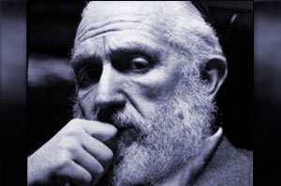
Rabbi J.J. Hecht

"Tell him to wait for me outside of the church. I'll be there in 15 minutes."
As Rabbi Hecht ran out of his office, he shouted to his secretary to cancel all of his appointments for the rest of the day. He dashed into his car and drove to the address of the church in Manhattan in record time. He stopped his car with a screech--on the sidewalk!--in front of the steps of the church. He ran up the steps of the church, where Yoav was waiting with the priest.
"I need a green card," Yoav told the rabbi, defiantly.
"You need a neshama (soul)," Rabbi Hecht told him boldly.
“The church is promising me a green card in 6 months if I convert," Yoav countered.
"I'll get you one in 3 months," said Rabbi Hecht.
Yoav thanked the priest for all of his help, gathered his little bundle of belongings, and got into Rabbi Hecht's car (still parked on the sidewalk). When they arrived in the NCFJE office, Rabbi Hecht told Yoav, "Anything you need, any time you need, you come to me." Rabbi Hecht then introduced Yoav to some of his sons, saying, "These are my sons and now you are like another one of my 12 children."

Found Yoav an Apartment and a Job
Over the next few days, Rabbi Hecht found Yoav an apartment and a job. Once every week or so, Yoav would inquire about the green card. "I'm working on it," Rabbi Hecht would tell him.
One day Yoav arrived at the office looking for Rabbi Hecht. The secretary told Yoav gently that Rabbi Hecht had passed away the week before. After Yoav got over the initial shock, he asked, "How am I going to get my green card now?" The secretary just shrugged.
The story could end here, and probably no one would be the wiser about another one of the thousands, maybe hundreds of thousands of people whose lives Rabbi Hecht personally touched, changed, saved. But it doesn’t.
Soon thereafter, Yoav became engaged to Alba, who had been working in the Kiddie Korner Preschool of Congregaton Bnai Abraham Synagogue in Brooklyn Heights. Alba asked her boss, the rabbi of the Congregation and director of Chabad of Brooklyn Heights, Rabbi Aron-Leib Raskin, to officiate at the wedding.
The rabbi happily agreed, and then promptly invited Yoav to come see him so they could get acquainted. In their meeting, Yoav told his story, speaking in loving and respectful terms about Rabbi JJ Hecht and how Rabbi Hecht had literally saved him, body and soul.

Discovers that Rabbi Raskin is a
Grandson of Rabbi J.J. Hecht
That’s when Rabbi Raskin told Yoav that he was Rabbi Hecht's grandson! Yoav became extremely excited, and doubly happy that this was the rabbi who would officiate at their wedding.
Not only that, when Rabbi Raskin heard that Yoav still didn’t have the green card, he told him that as Rabbi Hecht’s grandson, he was duty bound to take care of it. A highly energetic fellow, very much in the style of his grandfather, Rabbi Raskin succeeded in helping Yoav find a better job, and volunteered to be his sponsor for a green card, and thus was fulfilled the final clause of his grandfather's promise.

Source: Adapted by Yerachmiel Tilles from an article by Rabbi Aron-Leib Raskin in L’ChaimWeekly (#980).

Biographical note: Rabbi Yaakov Yehuda ("J.J.") Hecht (24 Cheshvan 1923 - 15 Av 1990), was sometimes described as the Lubavitcher Rebbe's Foreign Minister. In 1945, he was appointed the official director of the National Committee for the Furtherance of Jewish Education (NCFJE). In 1953 he started one of the first camps for religious Jewish girls, Camp Emunah. In the 1970’s he became the administrative head in Crown Heights, Brooklyn, of both Hadar HaTorah Yeshiva and Machon Chana Seminary. Rabbi Hecht also was the official translator of the Rebbe's talks to children and for the farbrengens on the radio. The Rebbe once described him publicly as one of "the chasidim who share deep soul bonds with him."
Connections: Seasonal -- 15th of Av (2013: July 21-22) is 1) "Jewish Matchmaking" Day; 2) the 23rd yahrzeit of Rabbi Hecht.

Reprinted from last week’s email of Kabbalahonline.org, a division of Ascent of Safed.
www.ascentofsafed.com ascent@ascentofsafed.com

It Once Happened

The Power of Properly Reciting Shema

During the times of Rabbi Shneur Zalman, founder of Chabad Chasidism, a law was passed to forcibly relocate Jews from rural villages to larger towns. This particularly harsh decree left many Jews destitute, without a source of livelihood, and a great deal of money was needed to alleviate their plight. Not only were many poor families without basic necessities, but officials had to be bribed to leave the Jews in peace. To this end, Rabbi Shneur Zalman began traveling extensively throughout the region asking for donations.

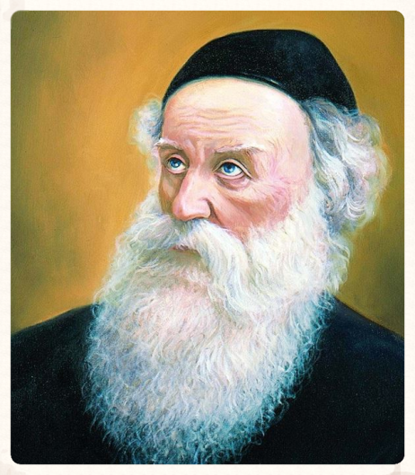
Rabbi Shneur Zalman

One such mission took Rabbi Shneur Zalman to the district of Vohlin, not far from the city of Toltshin, where Reb Boruch, the Baal Shem Tov's grandson, resided. Rabbi Shneur Zalman decided to visit Reb Boruch and Reb Boruch was delighted by the honor.
"What brings you here?" Reb Boruch asked.
"Well," Rabbi Shneur Zalman replied, "I am raising funds to convince the government officials to leave the Jews alone. The pitiful plight of my brethren is too much to bear."

Surely Such a Decree Could be
Averted on a Spiritual Level
Reb Boruch was surprised. "But surely you could have averted the decree on the spiritual level! Why are you actually going around collecting money?"
Rabbi Shneur Zalman explained: "I am only following a precedent. When our Patriarch Jacob was in danger, no doubt he could have alleviated the harsh decree in a spiritual way, without having to placate his brother Esau with gifts. Yet we see that he declared, 'I am sending a present to my lord Esau...that he be appeased.'"
Reb Boruch remained unconvinced. Rabbi Shneur Zalman was a great tzadik; why did he have to lower himself to act within the natural order? "But why didn't you just teach them the meaning of 'Echad' ('One') according to my grandfather's teachings? The decree would then have been automatically nullified!"

Your Grandfather’s ‘Echad’
Caused this Terrible Decree
"It was your grandfather's 'Echad' that caused this decree in the first place,' Rabbi Shneur Zalman replied. He then revealed the following:
After the Jews were expelled from Spain in 1492, there was not one country willing to take them in. The reason for this (as with everything else that happens in the physical world) originated in the higher spheres. In heaven, the ministering angels representing the various nations were arguing among themselves. "We don't want the Jews to live in our land!" each angel cried. "The first thing they'll do is build synagogues and houses of study. They'll learn Torah and they'll pray. We don't want them to declare 'Hash-m Echad - G-d is One!' "
The angels were afraid that this declaration of G-d's unity would nullify their very existence, much as darkness is dispelled in the presence of light. This spiritual reality was reflected down below, and the leaders of each nation refused to accept the Jews. There was only one angel who was not afraid, the ministering angel of Poland. In fact, he saw this as a golden opportunity to increase his own impure powers.
"They don't scare me," he declared. "I will take them in and it will be to my advantage. It is true that they'll build yeshivas and study Torah, and they will declare 'G-d is One.' But they will not have the proper intentions, and I will grow stronger."

The King of Poland Agreed to
Accept a Bribe from the Jews
And so it came to pass. The king of Poland agreed to accept a bribe - a pile of money as high as a mounted Cossack holding a spear upright.
Indeed, the Jews arrived in Poland in droves. They built synagogues and houses of study, established businesses, learned Torah and recited the "Shema" ("Hear O Israel, the L-rd is our G-d, the L-rd is One"). And, as the ministering angel had predicted, they did not have the proper intentions. The angel was delighted that his plan was working. His own powers were increasing from day to day. Unfortunately for him, however, the Baal Shem Tov came along and taught the Jews a dimension of "Echad" that was entirely different.

“That’s Not Fair!”
"That's not fair!" the angel of Poland cried. "The deal is off-the bargain is null and void! I only agreed to accept them under the terms of the old 'Echad,' not the new one!"
Down on earth, the Jews would have to find another home. The noose was tightened around the throat of European Jewry, and many Jews were expelled from their villages.
"Now do you understand?" Rabbi Shneur Zalman concluded. "The new law is a direct result of your grandfather's 'Echad,' and that is why money is once again needed to avert the harsh decree..."

The Importance of Giving
Tzedaka Properly
By Daniel Keren

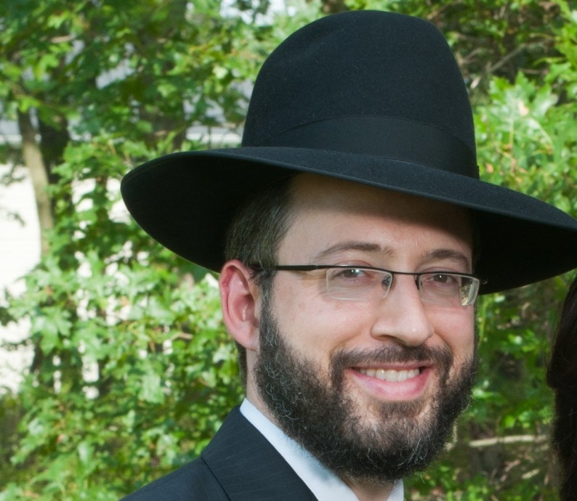
Rabbi Ari Marburger

On July 4, 2013, a special Yarchei Kallah Event organized by Hakehl was held in Flatbush. One of the speakers was Rabbi Ari Marburger, dayan of the Bais Din Mayshorim of Lakewood, NJ and author of the ArtScroll sefer “Business Halachah” who addressed the topic of “Hilchos Tzedaka and Maaseh Kesafim: Practical Guidelines, Situations and Solution
Rabbi Marburger started his shiur be explaining the importance of giving tzedakah properly. He explained that Yirmiyahu HaNavi spent many years trying to turn Klal Yisroel from their evil ways to do teshuvah. He warned them repeatedly that unless they improved the holy Bais Hamikdash would be destroyed.
When those dire prophecies did not succeed in transforming the behavior of the Jewish nation, Yirmiyahu cursed them that their wives would become almanos and their children would be transformed into yesomim. Yet when this had no effect, Jeremiah finally in frustration davened to Hashem that even when those Yidden wanted to give tzedakah, they should not give their charity to worthy recipients.

Charity to an Unworthy Person
Or Cause is not a Mitzvah
The halacha, Rabbi Marburger explained is that if one gives tzedakah to an unworthy person (who is not truly poor) or cause, he has not performed a mitzvah. The mitzvah of charity when done properly is a great protection for a Jew.
Why don’t we recite a brocha when performing the mitzvah of giving tzedokah? The Rivad explains that one doesn’t say a blessing when performing this commandment because of our concern for the feelings and dignity of the oni who is on the receiving line of the mitzvah.

Approached by a Poor Man While Davening
What if a person is davening and is approached at that time by an oni? He is not, Rabbi Marburger said, obligated to interrupt this davening which is a mitzvah in order to perform another mitzvah (the giving of charity). But, this applies only if one is involved completely in the mitzvah of praying.
If, however during the davening one is also checking the emails on his cell phone or texting, one cannot claim anymore to be totally involved in the mitzvah of praying and no longer can he claim an exemption from the mitzvah of giving tzedakah to the poor man.

Rav Moshe’s Solution
Rav Moshe Feinstein knew that in the course of his davening a number of oniyim would come by where he was praying in order to solicit a donation. Because he was truly and completely involved in that mitzvah and was therefore exempt from having to interrupt and give the poor a donation, he would nevertheless be prepared by in advance by placing a supply of coins on his shtender. That way the oniyim knew to go directly to Rav Moshe’s shtender and take one of his coins and not disturb the Gadol Hador in his davening.

Reprinted from the July 10,2012 edition of the Flatbush Jewish Journal.

Who's Who

The “Meor Hagola”

Rabbi Gershom ben Yehudah Hakohen (960-1040), also known as "Meor Hagola," the Light of the Exile, lived in France. He was one of the greatest scholars of his time and was famous for his Talmudic commentaries, legal responsa, and penitential prayers, but especially for the social legislation dealing with family life which he enacted.
Among others, he forbade the practice of having more than one wife, and of opening another person's mail. This legislation was accepted by all the Jews of Europe and is binding on us to this very day. He established the first yeshiva on the Rhine, which attracted the greatest scholars.

Reprinted from this week’s email of “L’Chaim,” a publication of the Lubavitch Youth Organization, in Brooklyn, NY.

